**How to Guide a Team for the MCM/ICM?** Xiaofeng Gao

Frankly, the secret of our success consists of only three words:

be *novel*, be *professional*, and be *beautiful*.

**Be Novel, Like a Scientist**

At the very beginning of the MCM in 1984, when Ben Fusaro proposed a new competition parallel to the William Lowell Putnam Mathematical Competition, he hoped that students would use mathematical tools to explore real-world problems.

Grasping the essence of MCM/ICM, contestants should view themselves as scientists searching for the solution to open-ended application problems rather than as students sitting through an exam. Hence, in considering the problem and writing the paper, students should show their understanding of the problem, their line of thought, and how they tailored their solution to the speciﬁc problem, instead of introducing some general solution and then explaining the results.

Speciﬁcally, undergraduate students in Shanghai Jiao Tong University usually have the opportunity to join research labs or join the Participation in Research Program to learn how to become a researcher. They are trained to face unsolved problems, read contemporary literature, discuss state-of-the-art research, and think individually and independently. Such training helps a lot to improve the novelty of their solutions.

For instance, Yiming Zhang, member of the Outstanding team on the Zambezi River Dam Problem (also the INFORMS Award Winner) said:

I never thought that laboratory research could play a role in this contest. However, my actual experience proved that modeling and researching can be interlinked. When our team was designing the framework of the model, a paper by some researchers at Microsoft Research came to mind [Yuan et al. 2016]. I had read it earlier when working on the topic prediction problem for social networks. Its hierarchical and modular structure seemed quite suitable for this modeling problem. Thus, during the design of our model, I learned from its ideas and also from the authors’ schematic style.

Another example is Zhiying Xu, member of an Outstanding team on the ICM Airport Security Problem (also the Leonhard Euler Award Winner). She said:

Most students easily think of cellular automata or a queuing model for the Airport Security Problem, which are dreary, cliched, and lack novelty. However, I did research on multicast in ad-hoc networks in my sophomore year in the lab of Industrial Internet of Things (IIOT) at Shanghai Jiao Tong University. I read a lot of papers about scheduling optimization during that period. Although it was a year ago and my research focus has changed since then, the idea of Lyapunov optimization and the back-pressure algorithm [Neely 2010] dawned on me. Although the background was very different, the problem was essentially similar. Thus, I adapted these models and got an excellent result.

Novelty is one of the most important issues that makes a team stand out above the rest.

**Be Professional, Like an Analyst**

After the model construction, you’ve just ﬁnished only one-third of the task! The next step should be explaining the “superiority” of your design. Problem clariﬁcation, assumption justiﬁcation, and model explanation are the ﬁrst and foremost things to discuss. Next, theoretical proofs, numerical tests, visual analysis, sensitivity tests, case studies. . . : Many methods could be adopted to support your idea. The bottom line is to provide evidence for your approach.

At this point, you should be professional, like an analyst: Prove the efﬁciency, effectiveness, and priority of your approach, using any available means. Also, the negative points—including the things that you cannot accomplish, the future work that you may consider, and the weaknesses of your model—should all be carefully evaluated in your solution paper.

For instance, Yisen Yao, member of the Outstanding team on the Zambezi River Dam Problem (also the INFORMS Award Winner) said:

Before entering the MCM/ICM Contests, I considered building the model as the most difﬁcult step. However, after the competition, I realized that there is not a single gold standard for the model, as long as you can make a strong case for your solution. It is the process of collecting data, solving model formulas, and running simulations that makes all the difference. Facing great quantities of formulas and numbers, it is a huge challenge for participants to summarize their models with concise words and reasonable formulas. For example, in this contest, we used a wide range of data sources, such as sea-level maps from Google Earth and the data of average precipitation from the Zambezi River Authority. Additionally, we used MATLAB for our simulation, which makes our result more accurate and credible.

In other words, after the model construction, the most important thing is analysis and justiﬁcation.

**Be Beautiful, Like an Artist**

Third, a good solution paper should be treated like a work of art. You

should write the paper like an artist, paying attention to every possible aspect, especially the organization, the visualization, and the presentation.

For example, Duxing Hao, member of the Outstanding team on the Migration to Mars Problem (also the INFORMS Award Winner), said:

When it comes to the highlights of our paper, illustration should surely be the ﬁrst. Given our paper’s title (“Society Planning: Model, Sim-ulation and Visualization”), we spent lots of time on “visualizing” numerical results [see **Figure 1**.]. Our principle is that by reading the summary part and just the images, readers should be able to grasp the idea, the model, and all essential results of our paper. To the basic caption for a ﬁgure, we added direct conclusions from the ﬁgure and pointers to corresponding paragraphs giving detailed discussion. These reader-centered features really helped in organizing our paper and clarifying the structure. Besides, one should always read published articles in the relevant research area and imitate their ﬁgure styles and paper organization as much as possible.

*Every* part matters in the contest: not just the main body, but the title, the abstract, the outline, the references, and if required, the letter, advertisement, or nontechnical report. In the Judges’ Commentary on the Space Junk Problem in 2016, Catherine A. Roberts said: “Meritorious paper 47676 from Shanghai Jiao Tong University was the exemplar in regard to citations” [Roberts 2016] (Team 47676 was also one of my teams that year). This shows that every detail may leave a deep impression on the judges, bringing more possibilities of the Outstanding award.

Be novel, be professional, and be beautiful. I hope that in the future, more students and advisors will participate in this intellectually challenging yet rewarding competition and enjoy their journey.

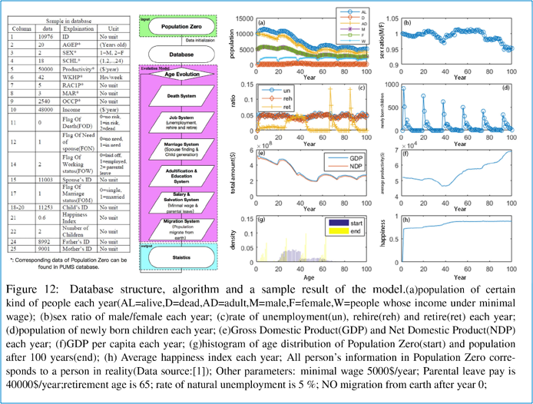

**Figure 1.** The visualization example from Duxing Hao’s team for the Migration to Mars Problem.